ANN Re entry securities @Europe

Fake Exits
+ EWI
Perdida de la mmov 200 con VIX>30
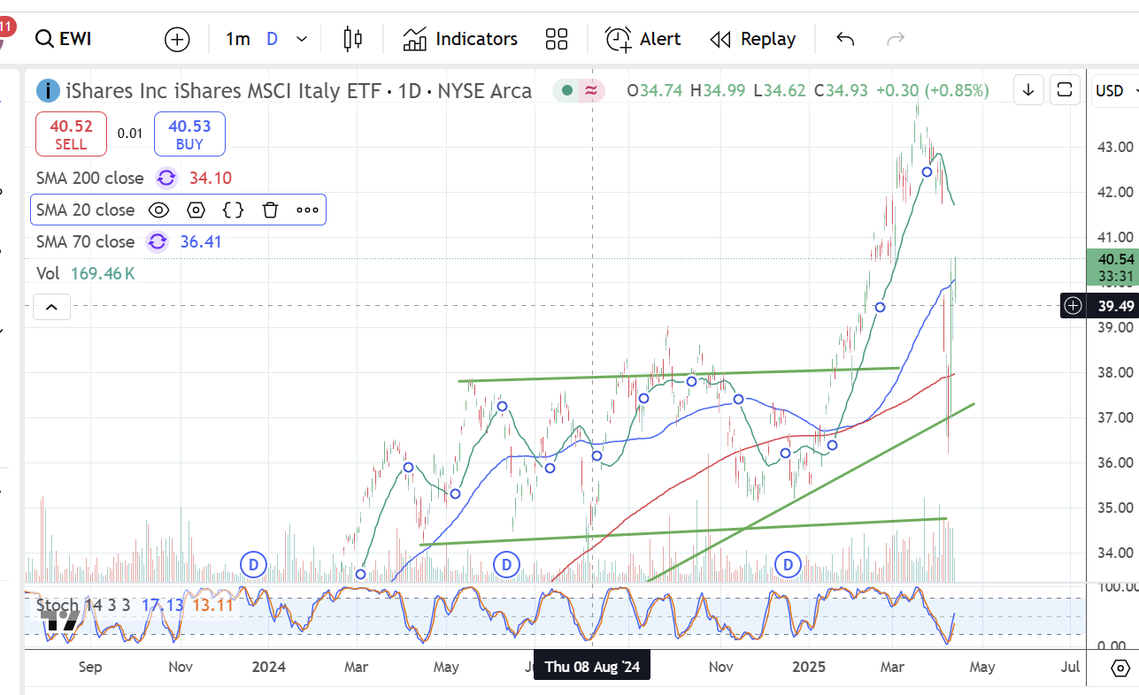
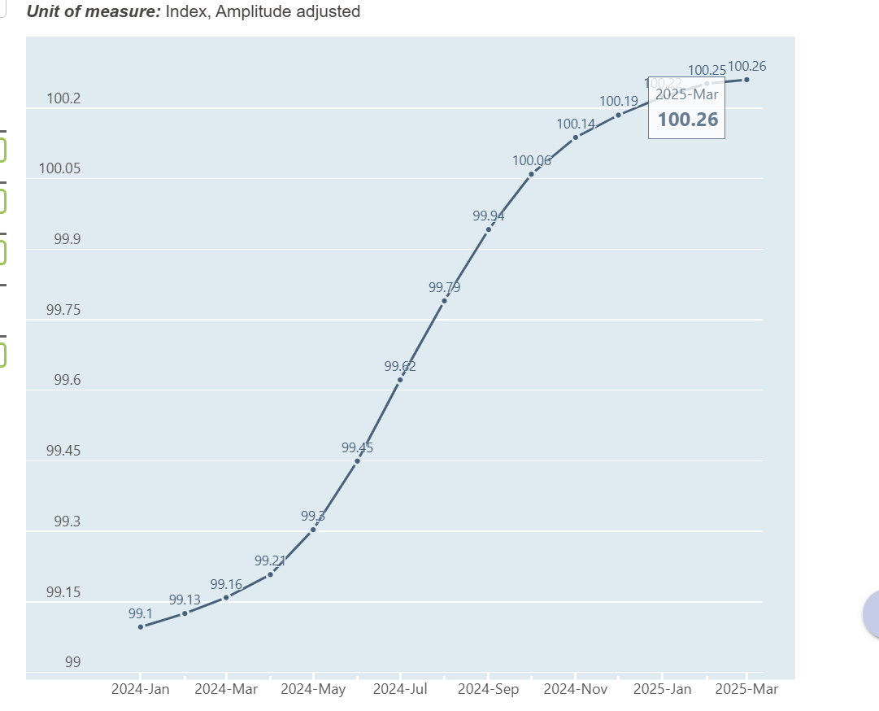
https://data-explorer.oecd.org/vis?lc=en&vw=tl&df[ds]=dsDisseminateFinalDMZ&df[id]=DSD_STES%40DF_CLI&df[ag]=OECD.SDD.STES&dq=ITA.M.LI...AA...H&to[TIME_PERIOD]=false&pd=2024-01%2C

+ EWY South Korea resists. LEI at best state
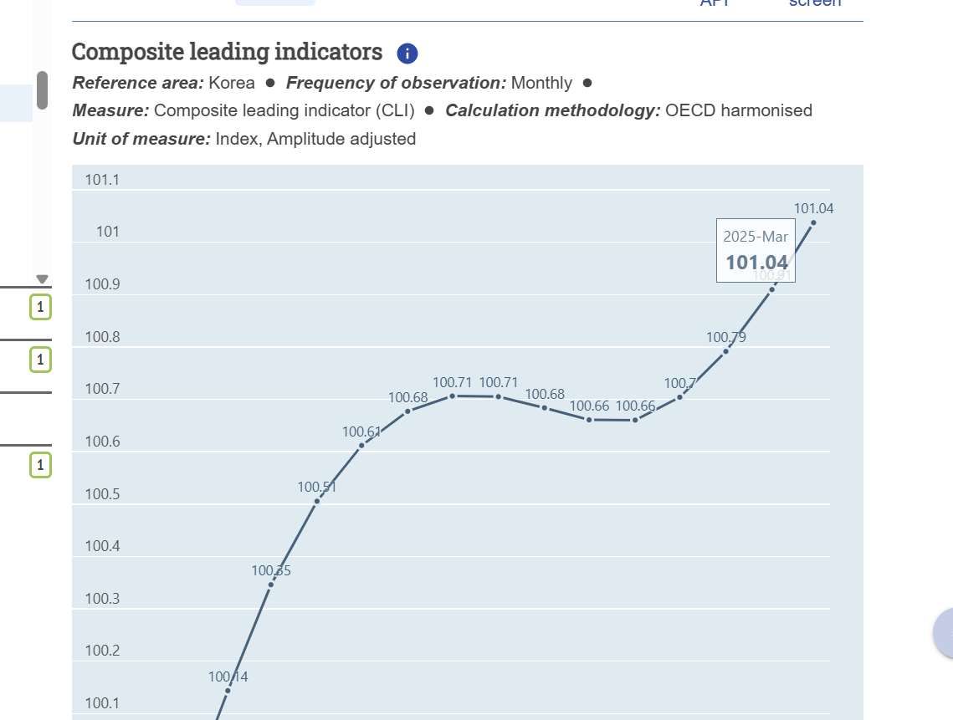

+ Major four European: VGK, FEZ
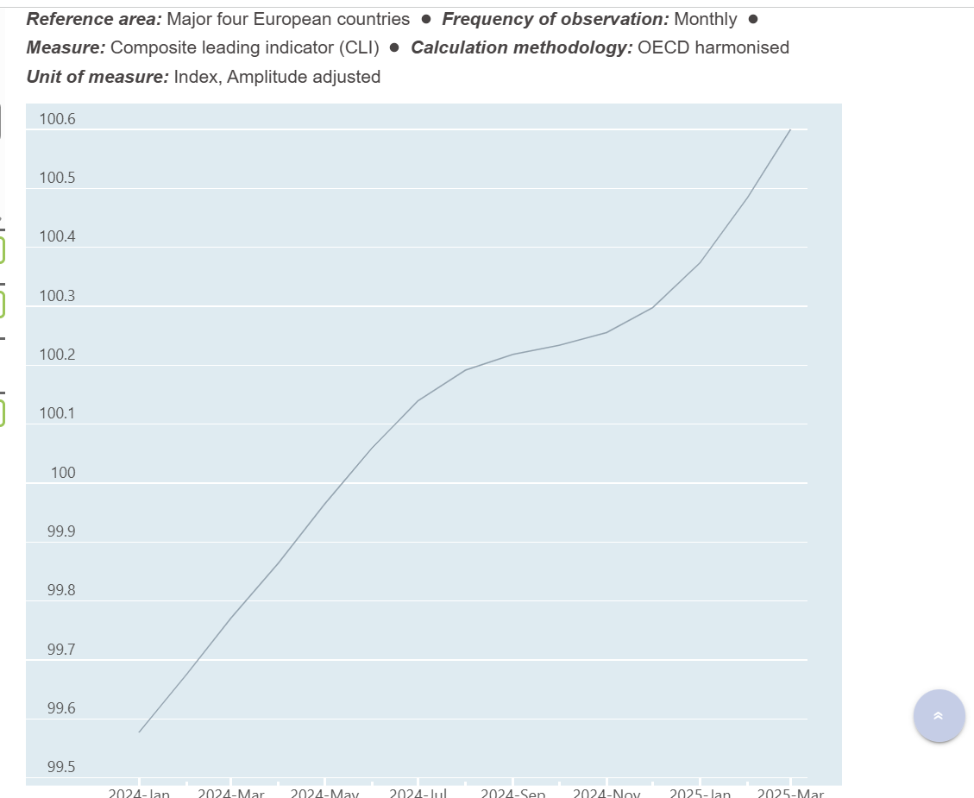

+ EWQ
